|  |  |
| --- | --- |
| Date | 08 November 2022 |
| Team ID | PNT2022TMID28449 |
| Project Name | A Novel Method for Handwritten Digit Recognition |
| Maximum Marks | 2 Marks |

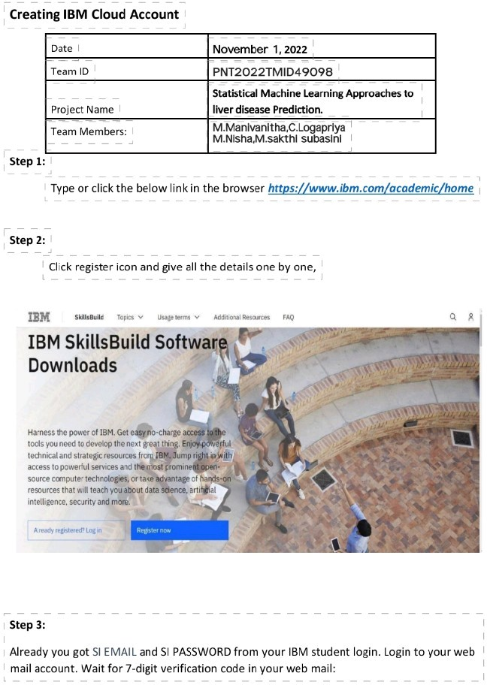

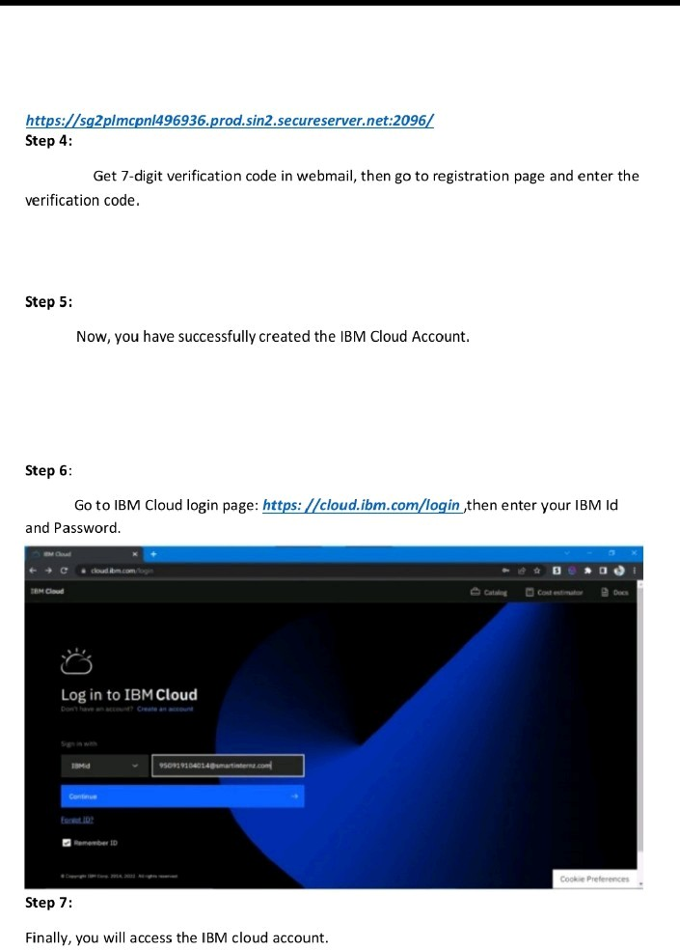

Nithesh Derin Joan account

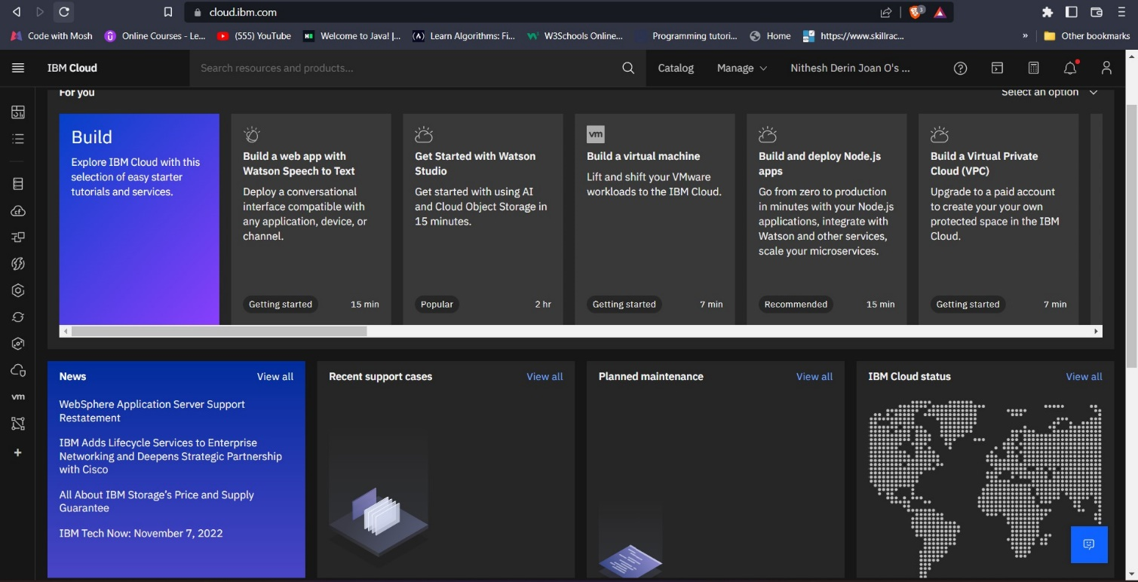

Perumal Account

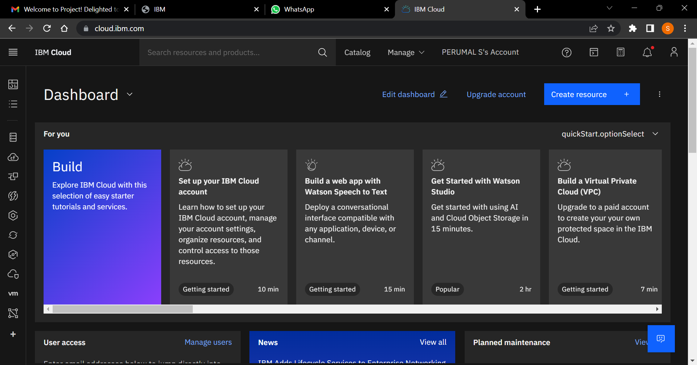

Om Prakash Account

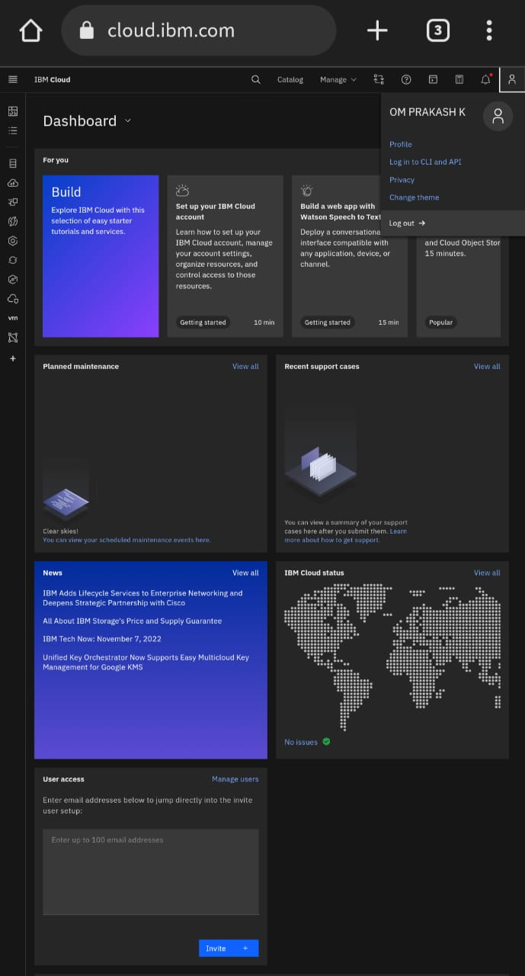

Srimanmuthuraj Account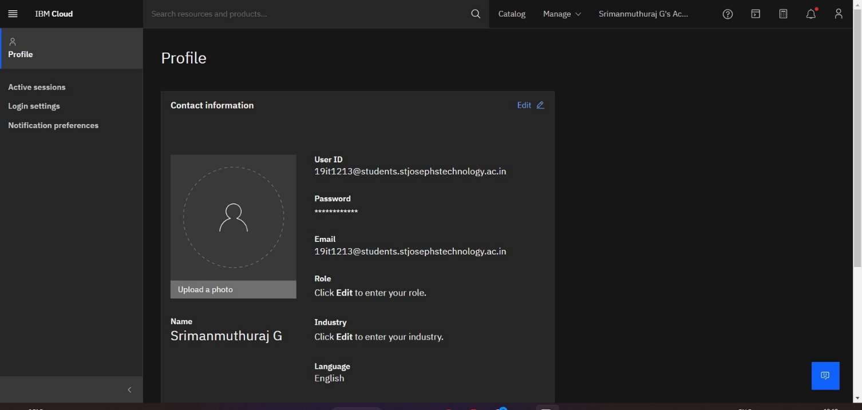

Mukesh Kolappan Account: 